CoastWise

# A Gamified Watershed Design Toolkit for Coastal Resilience Using the Stormwater Management Model

### Overview

#### CoastWise is an online tool that helps coastal communities in Virginia understand flood risks and test different solutions. It shows how storms and tides affect neighborhoods and lets you explore how natural options like rain gardens and built systems like pipes and tide gates can work together across the whole watershed.

### Purpose

### What Is CoastWise?

CoastWise is an interactive flood simulator where **you get to be the decision-maker**.

Imagine your town is about to get hit with a big storm. Will it flood? What if it happens at high tide? Can you protect your community from flooding?

With CoastWise, you can:

* Choose a storm with real-time tide data
* Try out real-world flood solutions

#### 

### What You Get to Test

CoastWise lets you run **six different flood plans**. Each one gives you a different combination of tools to fight flooding. Here's what you'll try:

1. **Baseline** – No help at all. No rain gardens. No tide gate. Just rain, pipes, and flooding.
2. **Tide Gate Only** – Puts a one-way gate on the pipe. It lets rainwater flow out, but blocks ocean water from coming back in during high tide.

#### 

1. **Green Infrastructure Only** – Adds rain gardens and barrels in neighborhoods to catch water before it hits the street.

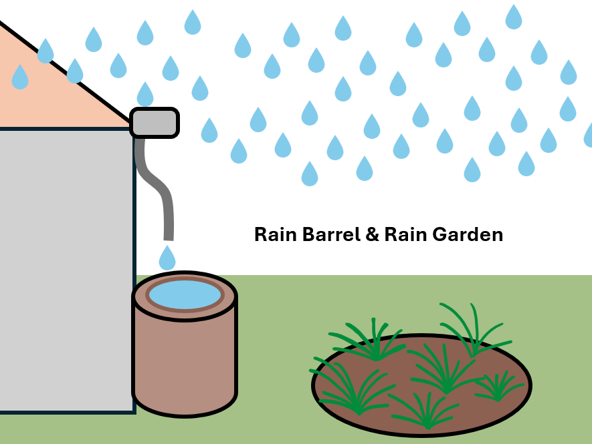

1. **Green Infrastructure + Tide Gate** – Combines your custom rain barrels and rain gardens selections along with a tide gate.
2. **Max Green Infrastructure** – Puts in the most rain gardens and barrels possible across the watershed.
3. **Max + Tide Gate** – Goes all in with everything: tide gate and maxed-out green infrastructure.

Each time, you’ll see **how the water behaves differently**, how much floods, how much drains, and how much it all costs.

For each of the six scenarios, the **program will also test a 20% increase in rainfall**—meaning your chosen rainfall plus 20% will be tested again. This represents the projected future rainfall.

### Step-by-step instructions

Go to the CoastWise website. Log in or create an account.

###### STEP 1: Choose Your Scenario

|  |
| --- |
| **→** Pick your units: U.S. Customary (American) or Metric (SI) |

###### 

|  |
| --- |
| * Choose the moon phase: 🌕 Full Moon? 🌓 Half Moon?   This is a fall back because the program will automatically pull real-time local tide data; however, if that is unavailable then, it will go to your chosen moon phase. |

|  |
| --- |
| * How long is your storm? * Pick how big it is (called a **“return year”**) * A 12-hour **10-year storm**: (10% chance of occurring each year): 4.66 inches * A 12-hour **100-year storm**: (1% chance of occurring each year): 7.82 inches   The amount of rainfall (in inches or cm) for each return period depends on how long the storm lasts — that's the duration.  The total rainfall **goes up**:   * when storms last longer, * or when you pick rarer, more extreme return periods.   Think of a return year like rolling a die - a 10-year storm is like rolling a 10 on a 10-sided die, you might roll it once in 10 tries… or twice… or not at all. But the chance of rolling a 10 is always 1/10 = 10% |

###### 

|  |
| --- |
| * Pick whether the storm happens at **high tide** or **low tide**   *Why this matters:* Flooding gets worse if it rains during high tide. The water has nowhere to go. |

###### 

|  |
| --- |
| * Click **“Apply Settings”** to test your choices above. |

###### 

###### You will see figures for rainfall and tide specific to your units, along with tide alignment, duration, and return period.

###### 

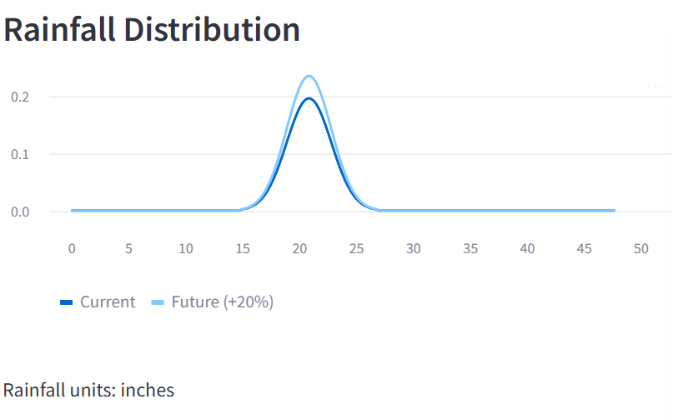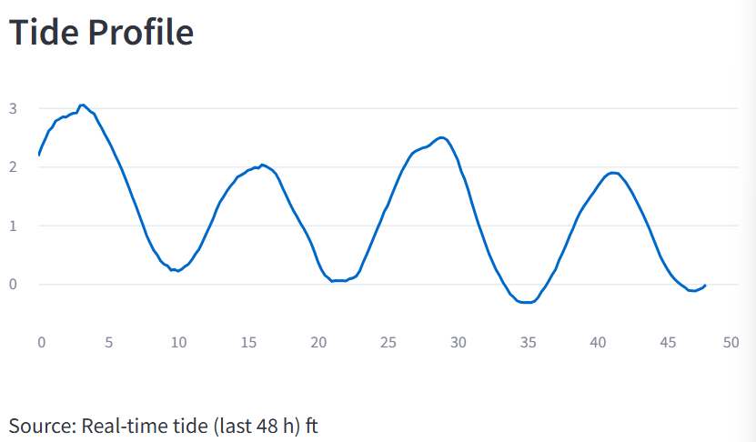

###### STEP 2: Run a Baseline Simulation

|  |
| --- |
| * Click **“Run Baseline Scenario”** to test what would happen in a big storm **if we didn’t do anything to help**. |

**AS A NOTE, YOU CANNOT DO ANYTHING ONCE YOU CLICK A BUTTON, AND YOU SEE THE RUNNING AT THE TOP RIGHT CORNER.**



|  |
| --- |
| You’ll see what happens with:   * 🚫 **No tide gate** (so water can flow in and out freely—even from the ocean) * 🌱 **No green infrastructure** (no rain gardens or barrels to catch or slow the water)   This is your **starting point**. It shows the “worst case” version of the storm. |

###### 

|  |
| --- |
| **What’s Happening Behind the Scenes?** When you click the button, CoastWise runs a flood simulation using **SWMM**, yes say, “*swim*” outloud when talking about the model, and it stands for the Stormwater Management Model. This is a real computer model that engineers use to figure out how rainwater moves through a city using physics equations.  It’s like:   * Pouring water on a **virtual neighborhood** * Watching where it **flows**, where it **soaks in**, and where it **floods** * Tracking how much water the pipes can handle   This baseline model shows how your chosen storm would behave **with no help from tide gates or green infrastructure**. So when you try different solutions later, you can compare and see what works!  Below is the baseline scenario for my chosen setting. |

###### 

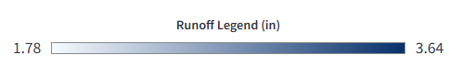

###### STEP 3: See Where the Water Comes From

|  |
| --- |
| After you run your baseline scenarios, CoastWise shows you **runoff results** for each part of the watershed. These areas are called **subcatchments**. Water from that area tries to **drain to a point**, like:   * A **storm drain** * A **pipe inlet** * Or another **subcatchment** nearby |

**Subcatchments in the Watershed**

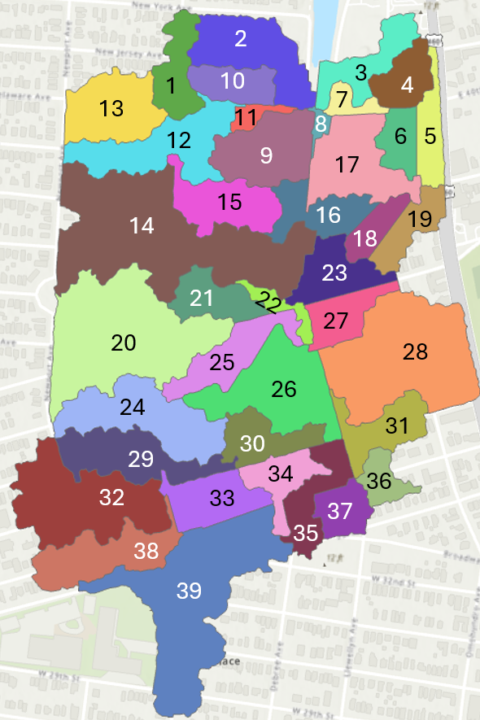 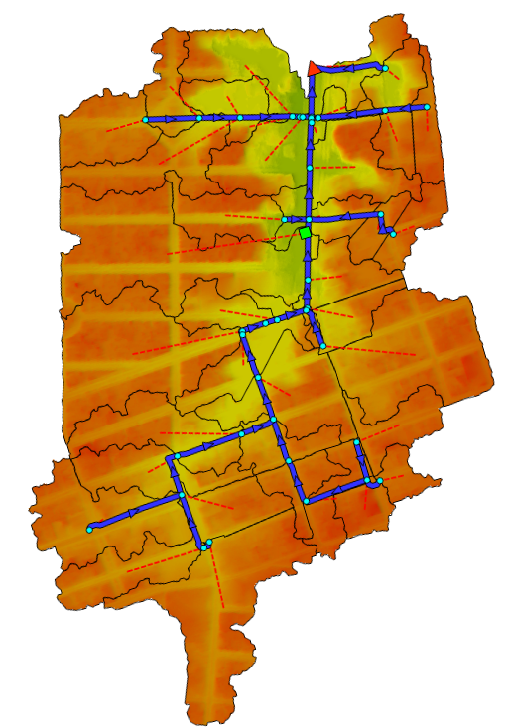

|  |
| --- |
| How Are Subcatchments Created? **Random lines? Nope.**  Subcatchments are made using two key things:   1. **An elevation map**  – It shows where the land is high and low  – Water always flows downhill, so this tells us where rain will go 2. **A pipe map**  – Pipes are placed in the low spots, where water naturally collects  – The pipe map is lined up with the elevation map so it drains correctly   The SWMM model uses both the elevation and the pipes to divide the land into **drainage zones** (subcatchments) |

**Elevation & Pipe Map**

|  |
| --- |
| Each subcatchment shows two important types of runoff: **1. 🛣️ Impervious Runoff (from hard surfaces)**  * This is water that flows off of **roads, rooftops, parking lots, and sidewalks** * These surfaces **can’t soak up water**, so the rain runs off fast into storm drains  **2. 🌿 Pervious Runoff (from natural ground)**  * This is water that flows off **grassy areas, dirt, or parks** * These surfaces **can soak in** some water, but not all of it—especially during big storms |

**Land Use Map of the Watershed**

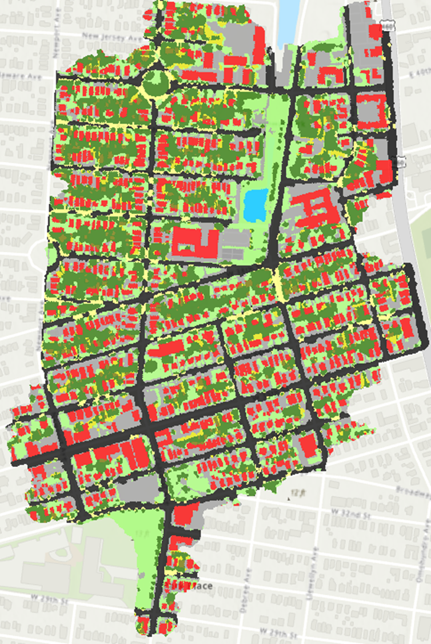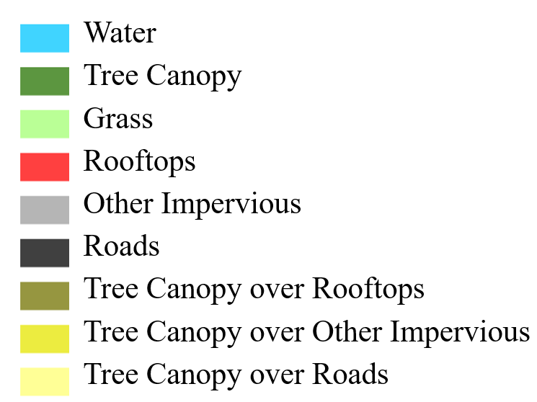

|  |
| --- |
| 🧠 What to Look For in CoastWise  * Which subcatchments have the **highest impervious runoff**? (Think: lots of buildings or pavement)   + Reorder the impervious runoff in descending order using the interactive table |

###### 

###### STEP 4: Run Max Low Impact Development (LID)

|  |
| --- |
| * What is an LID - a low impact development? These are stormwater solutions that try to **mimic nature** by slowing down, soaking up, or storing rainwater where it falls instead of letting it flood the streets or overwhelm pipes. |

|  |
| --- |
| * What are our two LID solutions we are using?  Rain Barrel  * A **rain barrel** is like a big **plastic drum** that **collects rainwater** from your roof. * Water flows from the **gutter downspout** into the barrel. * It **holds the water temporarily** so it doesn’t rush into storm drains. * Later, you can **use it to water plants**, or it slowly drains out after the storm.   ✅ *Good for small areas with roofs* ✅ *Cheap and easy to install* ❌ *Only stores water, doesn’t let it soak into the ground* Rain Garden  * A **rain garden** is a **shallow, bowl-shaped area** filled with **plants and soil** that **soaks up and filters rainwater**. * Water runs off driveways, roofs, or streets **into the garden**, where it **slowly soaks into the ground**. * The **plants help clean** the water and **reduce flooding** by holding it back.   ✅ *Handles bigger flows than a rain barrel* ✅ *Reduces pollution, recharges groundwater* ❌ *Needs space, soil that drains well* |

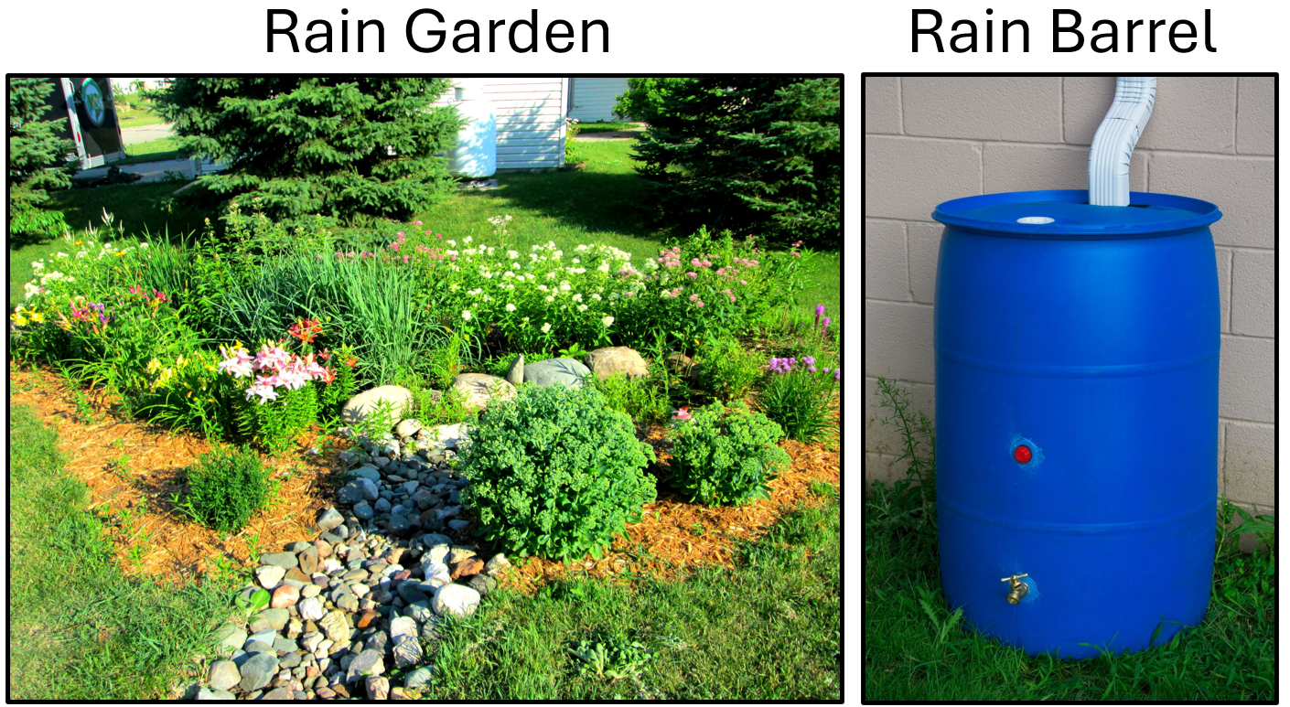

|  |
| --- |
| Rain Barrel Example *How fast does a rain barrel fill up?*   * The barrel is **55 gallons**, which is **7.35 cubic feet (ft³)**. * Rainwater flows from a **300 ft² roof** into the barrel. * To find out how much rainfall would fill it:   **Rain depth = Volume ÷ Area $\frac{7.35 {ft}^{3}}{300 {ft}^{2}} = 0.025 ft = 0.29 in of rain$**    **Only 0.29 inches of rain** over that roof area fills the entire barrel.  **It fills up fast** — after that, it overflows. |

|  |
| --- |
| Rain Garden Example *Think of a rain garden like a sponge in a bowl.*   * The **bowl** part is the raised edge (**berm**) around the garden — 6 inches tall. * The **sponge** is the **2-foot deep soil layer** that absorbs water. The sponge’s **porosity** (how much empty space is in it for water) is **0.453**.  **Water it can hold:**  * **Soil storage** = 100 ft² × 2 ft × 0.453 = 90.6 ft³ * **Surface storage (berm)** = 100 ft² × 0.5 ft = 50 ft³ * **Total capacity** = 90.6 + 50 = **140.6 ft³**  ***How much rain would fill it up?***  * If **500 ft² of yard area drains** into the 100 ft² rain garden $\frac{140.6 {ft}^{3}}{500 {ft}^{2}} = 0.2812 ft = 3.37 in of rain$    It takes about **3.37 inches of rain** over that 500 ft² drainage area to fill the rain garden. |

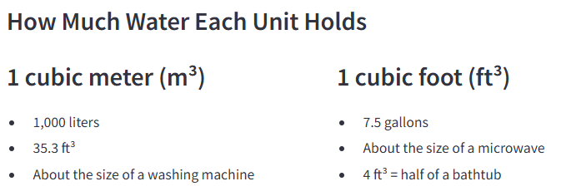

|  |
| --- |
| 🌧️ What Is a Drainage Area? When it rains, water runs **off roofs, driveways, and lawns** — this is called **runoff**.  That water always **goes somewhere**. The **drainage area** is the space where the rain **lands and then flows into** something like a **rain garden** or a **rain barrel**. |

|  |
| --- |
| 🌱 How Many Rain Gardens Do You Need? Let’s say we have a big grassy field — and we want to figure out **how many rain gardens we’d need to soak up the rain** from that area.  Each rain garden can handle water from **500 square feet** of land — but **only 400 square feet** of that is actually **draining into it**, because the rain garden itself takes up **100 square feet**.  To figure out the **maximum number of rain gardens**, we take the **total grassy area** and divide by **500**:  For example, if your grass area is **5,000 square feet**: |

|  |
| --- |
| 🏠 What About Rain Barrels? Rain barrels catch rain from **rooftops**.   * One **55-gallon rain barrel** can hold the rain from **300 square feet** of roof.   So we can do the **same kind of math**:  Take the **total roof area**, and divide by **300** to figure out how many barrels you’d need.  For example, if your school roof is **3,000 square feet**: |

|  |
| --- |
| This doesn’t mean we’d **build all 10** rain gardens and rain barrels — most people wouldn’t turn an entire yard into rain gardens — but it shows the **largest number you’d ever consider** based on how much land or roof you’re dealing with. |

**Land Use Map of the Watershed**



###### STEP 5: Your Custom LID Selections

|  |
| --- |
| 🛠️ The Process of Choosing LID Features When you select subcatchments in CoastWise, here’s what’s happening:   1. You select subcatchments — these are small drainage areas inside a watershed. 2. For each subcatchment, you choose whether to add:     * A rain garden, or    * A rain barrel, or sometimes both. 3. Every time you make a selection, the model records it in your custom LID scenario.   Once done selecting your infrastructure, click **Run Custom LID Scenario** |

|  |  |  |  |  |  |  |  |  |  |  |  |  |  |  |  |  |  |  |  |  |  |  |  |  |  |  |  |  |  |  |  |  |  |  |  |  |  |  |  |  |  |  |  |  |  |  |  |  |  |  |  |  |  |  |  |  |  |  |  |  |  |  |  |  |  |  |  |  |  |  |  |  |  |  |  |  |  |  |  |  |  |  |  |  |  |  |  |  |  |  |  |  |  |  |  |  |  |  |  |  |  |  |  |  |  |  |  |  |  |  |  |  |  |  |  |  |  |  |  |  |
| --- | --- | --- | --- | --- | --- | --- | --- | --- | --- | --- | --- | --- | --- | --- | --- | --- | --- | --- | --- | --- | --- | --- | --- | --- | --- | --- | --- | --- | --- | --- | --- | --- | --- | --- | --- | --- | --- | --- | --- | --- | --- | --- | --- | --- | --- | --- | --- | --- | --- | --- | --- | --- | --- | --- | --- | --- | --- | --- | --- | --- | --- | --- | --- | --- | --- | --- | --- | --- | --- | --- | --- | --- | --- | --- | --- | --- | --- | --- | --- | --- | --- | --- | --- | --- | --- | --- | --- | --- | --- | --- | --- | --- | --- | --- | --- | --- | --- | --- | --- | --- | --- | --- | --- | --- | --- | --- | --- | --- | --- | --- | --- | --- | --- | --- | --- | --- | --- | --- | --- | --- |
| Now, I’ll Walk Through an Example for Custom LID Selection:  The goal of low impact developments (LIDs) is to **slow down the flow** of water and reduce peak flooding — so placing rain gardens or rain barrels **upstream** in larger areas can help **delay how fast water reaches the system**.  An example strategy is to simulate a percent uptake rate like **50% uptake rate** — meaning **50% of rooftops or yards in each watershed adopt LID practices**. This represents a realistic community-scale effort where not everyone participates, but enough do to **make a measurable difference**. It helps planners see what kind of benefits could come from **partial but widespread adoption**, like you might get through incentive programs or local policy.  **While adding LIDs to either column you will notice it looks grayed out, but you can continue to type in numbers to the columns while this is occurring. Once you are done selecting, wait for the screen to “catch up” and become full color again. Then, Click Run Custom LID Scenario.**   |  |  |  | | --- | --- | --- | | Subcatchment | Rain Gardens | Rain Barrels | | 1 | 7 | 30 | | 2 | 7 | 70 | | 3 | 5 | 20 | | 4 | 1 | 30 | | 5 | 1 | 23 | | 6 | 7 | 25 | | 7 | 0 | 1 | | 8 | 0 | 0 | | 9 | 16 | 47 | | 10 | 0 | 61 | | 11 | 3 | 4 | | 12 | 26 | 82 | | 13 | 14 | 83 | | 14 | 124 | 240 | | 15 | 31 | 62 | | 16 | 4 | 26 | | 17 | 26 | 45 | | 18 | 1 | 45 | | 19 | 7 | 53 | | 20 | 62 | 180 | | 21 | 1 | 51 | | 22 | 0 | 5 | | 23 | 2 | 30 | | 24 | 35 | 82 | | 25 | 0 | 41 | | 26 | 13 | 112 | | 27 | 7 | 40 | | 28 | 32 | 180 | | 29 | 8 | 82 | | 30 | 4 | 50 | | 31 | 18 | 45 | | 32 | 18 | 160 | | 33 | 5 | 65 | | 34 | 18 | 35 | | 35 | 18 | 35 | | 36 | 18 | 21 | | 37 | 8 | 31 | | 38 | 15 | 53 | | 39 | 103 | 125 | |

|  |
| --- |
| What Happens When You Click “Run MAX LID Scenario” When you press the **“Run MAX LID Scenario”** button in the model, you’re telling the computer to:  Put the **maximum number of rain gardens and rain barrels** that could possibly fit in this watershed — based on how much grassy and roof area there is based on the land use map. |

|  |
| --- |
| Watershed Maps These maps show model outputs for stormwater runoff in a watershed under different rainfall and infrastructure scenarios. Each map represents spatial runoff conditions for subcatchments (labeled “Sub_1,” “Sub_12,” etc.), with results displayed in **inches of runoff**. The scale at the bottom (1.52–4.41 inches) is consistent across all maps, allowing direct comparison.  The black and red dots mark **junctions or nodes** in the stormwater system. Their color reflects performance or stress at those points:   * **Black dots** – locations that are managing flow within expected capacity. * **Red dots** – locations where runoff/stormwater pressure is exceeding capacity (problem areas or flooding risk).  Top Row: Custom LID vs Baseline under +20% Rainfall  * **Custom LID — +20% Rainfall (left):**  This scenario tests a 20% increase in rainfall intensity, but with **Custom Low Impact Development (LID) practices**. * **Baseline — +20% Rainfall (right):**  Same 20% increase in rainfall, but **without LID interventions**.    + Runoff depths are generally higher (darker blues).   + More red nodes appear, especially in the lower and central parts of the watershed.   + Indicates higher flood risk and less resilience in the system.   **Takeaway:** LID reduces both the amount of runoff and the number of overloaded nodes, even under future projected rainfall increases. Bottom Row: Tide Gate + Max LID (Current vs Future Rainfall)  * **Tide Gate + Max LID — Current Rainfall (left):**  This scenario assumes maximum adoption of LID practices plus tide gates (infrastructure preventing tidal backflow into stormwater pipes).    + Under current rainfall, the system performs well.   + Runoff depths are lighter overall.   + Very few red nodes remain, showing much lower system stress. * **Tide Gate + Max LID — +20% Rainfall (right):**  Same setup but with a 20% increase in rainfall intensity.    + Runoff increases compared to the “current rainfall” case (darker shades appear). |

###### 

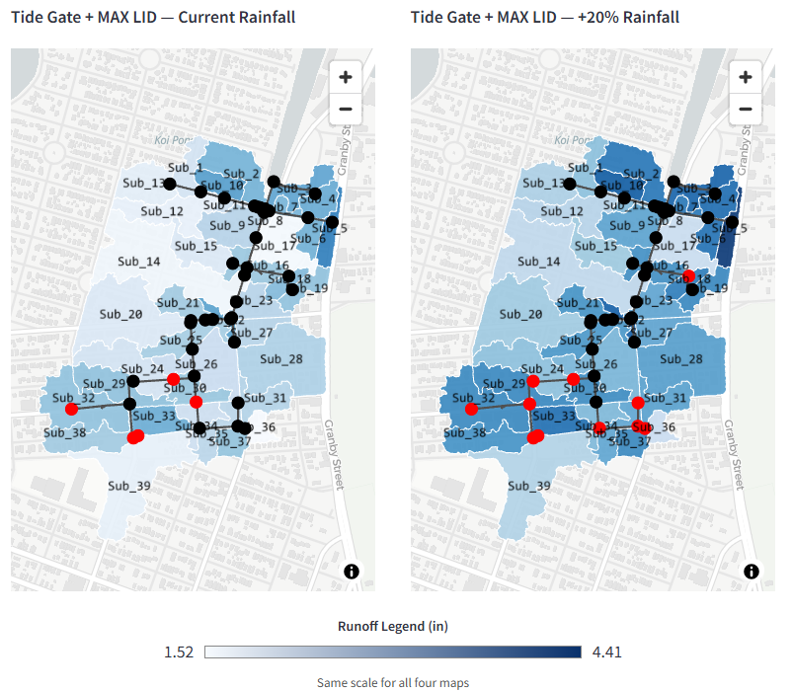

###### STEP 6: What’s Going On in Watershed Volumes: Flooding, Infiltration, and Surface Runoff?

|  |
| --- |
| All 12 scenarios are shown for Flooded Volume, which represents the amount of water that overflowed and caused flooding.  For Infiltration and Surface Runoff, only 6 scenarios are shown, since the presence or absence of a tide gate does not affect these processes.   * *Infiltration*: The amount of water absorbed into the ground through rain gardens or permeable surfaces. * *Surface Runoff*: The portion of water that flows over land into pipes — higher values indicate worse conditions. |

###### 

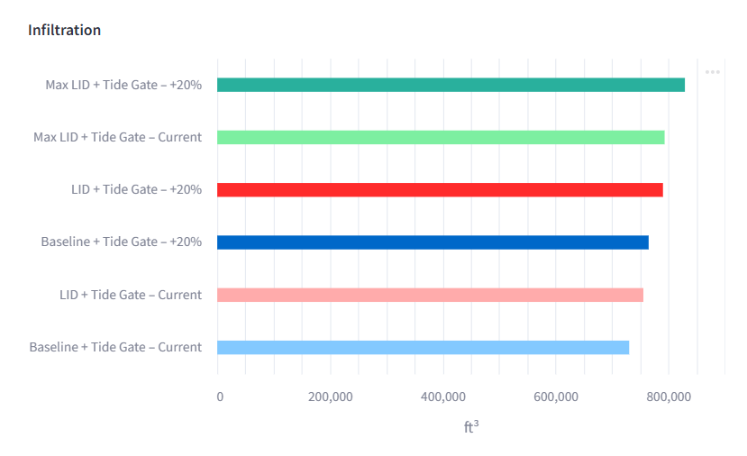

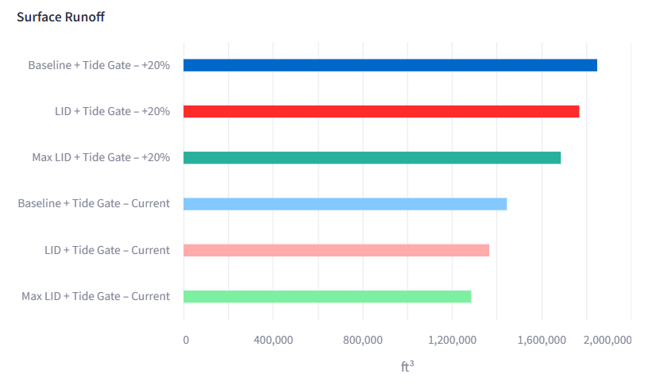

|  |
| --- |
| What Do We Learn?  * A tide gate alone prevents tidal flooding but does not improve runoff or infiltration. * Green infrastructure reduces runoff and increases infiltration but cannot prevent tidal flooding by itself. * The best results come from combining the two approaches. * A **Custom LID + Tide Gate** strategy offers a practical balance — it reduces both flooding and runoff at lower cost, without requiring every property in the neighborhood to adopt multiple LID measures. |

###### STEP 7: Download Your Excel Spreadsheet

|  |
| --- |
| After you’ve built your storm scenario, chosen your LID setup, and run the model — it’s time to **download your results**.  This spreadsheet has **everything you just did**:   * Which **storm** you picked (like a 10-year or 100-year event) * What **tide alignment** you used (high tide, low tide, etc.) * What **LID configuration** you built — which subcatchments had rain gardens or barrels * And the full **results**: flooding, infiltration, and surface runoff |

###### 

|  |
| --- |
| Why Do You Need This? Because this file lets you:   * **Compare different configurations** — What happens if you add more rain gardens? Or just use rain barrels? Did it reduce flooding? * **Test different storms and tides** — How does your setup perform under a worse storm? Or when the tide is high? * **Keep track of your work** — Instead of starting over every time, you can **see exactly what you tried**, and decide what to test next. * **Share your findings** — With classmates, teachers, or even use it for a presentation. The Excel file has the data to back up your decisions. |

###### Glossary

|  |
| --- |
| **Baseline** The "do nothing" scenario. No rain gardens, no rain barrels, no tide gate — just pipes, stormwater, and flooding.  **Return Period (Return Year)** How likely a storm is to happen in a given year. Example: A 10-year storm has a 1 in 10 (10%) chance of happening any year. Longer return periods = rarer, bigger storms.  **Tide Gate** A one-way flap at the end of a pipe.  ✅ Lets rainwater flow out  ❌ Blocks ocean water from coming back in during high tide  **Low Impact Developments (LIDs)** A design strategy using green infrastructure to reduce the impact of development on natural water flow. In CoastWise, LID = rain gardens + rain barrels.  **Rain Barrel** A large container that collects rainwater from a roof.   * Connects to a gutter downspout * Holds water temporarily * Good for small areas * Doesn't soak water into the ground   **Rain Garden** A shallow, bowl-shaped garden that captures rain and lets it soak into the ground.   * Filled with special soil and plants * Filters water * Reduces runoff and pollution   **Drainage Area** The land where rain falls and flows into a stormwater system, rain garden, or barrel. It could be:   * A rooftop (for a barrel) * A yard or street (for a rain garden)   **Subcatchment** A small area of land within a watershed that drains to a common point (like a storm drain or pipe). Each subcatchment has its own mix of rooftops, roads, grass, and pipes.  **Impervious Surface** Hard surfaces that **don’t let water soak in** — like rooftops, streets, and parking lots. More impervious surface = more runoff.  **Pervious Surface** Natural ground that **can soak in water** — like grass, soil, and parks.  **Infiltration** The process of water soaking into the ground. More infiltration = less flooding.  **Surface Runoff** Rainwater that flows across the surface instead of soaking in. High runoff = more chance of flooding.  **Flooded Volume** The amount of water that overflowed because the pipes and drainage couldn’t handle it — this is the water that causes street flooding.  **Max LID** The **maximum number** of rain gardens and rain barrels that could be placed across the watershed, based on available grass and roof area. Used to show the best-case scenario for LIDs.  **Custom LID** A setup you design yourself — choosing where you want rain gardens and barrels across different subcatchments.  **Storm Duration** How long the storm lasts — 2, 3, 6, 12, or 24 hours. Longer storms = more total rainfall.  **Storm Intensity** How much rain falls over time. Short, intense storms cause more runoff in less time.  **SWMM (Stormwater Management Model)** Say it like “swim”! A computer model engineers use to simulate how rainwater moves through a neighborhood — over land, into pipes, and through green infrastructure.  **Watershed** The total area of land where all the rain drains into the same pipe system or water body. |

###### 